Capstone Project On

Big Data Analytics on Customer Purchase Behaviour in E-Commerce industry
Submitted in the partial fulfilment of the requirements for the award of the degree of

MASTER OF BUSINESS ADMINISTRATION (GENERAL)

By
PATKULA VAISHNAVI
(24MBMA29)
MBA 2024-26

Under the esteemed guidance of
SREE LAKSHMI MAM
SCHOOL OF MANAGEMENT STUDIES
UNIVERSITY OF HYDERABAD

SCHOOL OF MANAGEMENT STUDIES, UNIVERSITY OF HYDERABAD, Prof. CR Rao Road
Gachebowli, Hyderabad, Telangana, 500046

DECLARATION

I, Patkula Vaishnavi (Roll No: 24MBMA29), hereby declare that the Capstone Project entitled “Big Data Analytics on Customer Purchase Behaviour in E-commerce Industry” submitted to School of Management Studies, University of Hyderabad in partial fulfillment of the requirements for the award of the degree of Master of Business Administration in General, is a record of original work carried out by me during my course called Big Data Analytics at School of Management Studies, University of Hyderabad.
I further declare that this report is the result of my own efforts and has not been submitted to any other University/Institute for the award of any degree, diploma, or fellowship. All sources of information used have been duly acknowledged in the references.

Place: School of Management Studies
University of Hyderabad
Date:

Signature of the Student
Patkula Vaishnavi
Roll No: 24MBMA29
School of Management Studies
University of Hyderabad

Chapter 1: Introduction

1.Introduction to the Study
The e-commerce sector has evolved into one of the most dynamic industries of the digital age. The increasing penetration of the internet, smartphones, and digital payment platforms has revolutionized how consumers discover, compare, and purchase products. Unlike traditional retail, online purchasing allows instant access to product variety, competitive pricing, and convenience of doorstep delivery.

In this highly competitive environment, understanding customer purchase behaviour is crucial for business success. Data analytics has become a key enabler for e-commerce firms to identify buying trends, predict future purchases, and tailor personalized recommendations. By analyzing customer data through big data tools and machine learning models, companies can develop insights that strengthen retention strategies and enhance profitability.

This report focuses on the application of big data analytics to study, predict, and interpret customer purchase behaviour within the e-commerce industry. The project utilizes a data pipeline architecture (Bronze–Silver–Gold) to ensure structured data flow, consistency, and accuracy before performing analytical modelling on multiple business use cases such as purchase prediction, segmentation, product recommendation, customer lifetime value estimation, and churn prediction.

2.Background of the Study
E-commerce has witnessed exponential growth globally. According to industry projections, global online retail sales crossed USD 6 trillion in 2024. With this growth, companies are generating massive volumes of customer data that can be harnessed for actionable insights. Giants such as Amazon, Flipkart, and Alibaba rely extensively on predictive models to understand consumer needs, manage inventory, and personalize marketing communication.
Traditional descriptive analytics that only explains “what happened” is no longer sufficient. Modern decision-making requires predictive and prescriptive analytics to anticipate “what will happen next” and “what action should be taken.” For example, identifying customers who are likely to churn allows proactive retention measures, while segmenting customers by value helps allocate marketing resources more efficiently.
This project replicates such an analytical environment by creating a structured data pipeline that automates data ingestion, transformation, and model building, thereby producing reliable analytical insights.

3.Problem Statement
E-commerce firms have access to large datasets containing customer demographics, transactions, and interactions. However, deriving meaningful insights from this data remains challenging due to issues such as inconsistent data quality, unstructured information, and lack of integration across platforms. Businesses struggle to accurately predict customer needs and preferences, which often leads to low repeat purchases, ineffective targeting, and customer churn.

This study addresses the following key question:
How can big data analytics and predictive modelling be leveraged to understand and forecast customer purchase behaviour to enhance personalization, retention, and customer lifetime value?

The project also explores the following sub-questions:

- Which factors influence online purchase decisions the most?
- How can customers be segmented for targeted marketing?
- How can churn and lifetime value be predicted effectively?
- How can recommendations improve customer engagement and conversion?

4.Objectives of the Study
The main objective of this study is to apply data analytics techniques to analyse and model customer purchase behaviour in the e-commerce industry.

Specific objectives include:

1. Understanding customer purchasing patterns and identifying behavioural trends.
2. Developing predictive models for forecasting purchases.
3. Segmenting customers based on purchase frequency and spending patterns.
4. Designing a recommendation system to enhance product cross-selling.
5. Estimating Customer Lifetime Value (CLV) for prioritizing key customers.
6. Predicting customer churn to assist retention planning.
7. Demonstrating how analytical insights can support decision-making in e-commerce firms.

5.Significance of the Study

Customer retention is far more cost-effective than acquisition — studies show it costs five times more to acquire a new customer than to retain an existing one. Hence, businesses that understand and predict customer needs gain a major competitive edge. This project highlights the strategic importance of big data analytics in:

- Identifying trends that shape customer buying habits.

- Supporting data-driven marketing and pricing strategies.

- Enhancing personalization through predictive insights.
- Improving operational efficiency by integrating analytics into business workflows.

- Demonstrating the role of analytics pipelines in structured decision-making.

By translating customer data into business intelligence, this study emphasizes how analytics-driven strategies can improve profitability and loyalty in the e-commerce space.

6.Research Methodology
This study follows an exploratory and analytical research design. It integrates data engineering and analytics techniques to convert raw e-commerce data into actionable insights through a multi-layered pipeline.
Data Source
The dataset comprises simulated e-commerce transactions that include:
- Customer demographics (ID, gender, age, region)

- Transactional details (product ID, price, quantity, mode of payment)

- Behavioural variables (purchase frequency, recency, monetary value)

7.Tools and Technologies

Databricks: For building and managing data pipelines

Python: For data preprocessing and modelling

Libraries: Pandas, NumPy, Scikit-learn, Matplotlib, Seaborn

Visualization: Databricks dashboarding tools

- Pipeline Architecture

The project adopts the Bronze–Silver–Gold architecture:

- Bronze Layer: Raw data ingestion and schema creation

- Silver Layer: Cleaning, transformation, and feature engineering

- Gold Layer: Model building for predictive and clustering analyses

This layered structure ensures scalability, data quality, and efficient computation.

8.Analytical Framework
The study is based on five key analytical use cases:

- Purchase Prediction – Predicts the probability of future purchases using Logistic Regression and Random Forest.
- Customer Segmentation – Groups customers by purchasing patterns
using K-Means clustering.
- Product Recommendation – Suggests products using Collaborative
Filtering.
- Customer Lifetime Value (CLV) Prediction – Estimates revenue potential using Regression models.
- Churn Prediction – Identifies customers likely to stop purchasing using Decision Tree and Gradient Boosting algorithms.

Performance of models was validated using metrics such as Accuracy, Precision, Recall, ROC-AUC, Silhouette Score, and R².

Ethical considerations included anonymized data usage, unbiased modelling, and transparency in analysis.

9.Analysis and Key Findings

- Data Overview

The dataset contained approximately 5,000 unique customers and over 50,000 transaction records. Electronics, Fashion, and Beauty emerged as top-performing categories, while 68% of transactions used digital payment modes. The data reflected the 80/20 rule — 20% of customers contributed to nearly 65% of total sales.

- Purchase Prediction

Recency and Frequency were found to be the most influential predictors of repurchase. Customers who made purchases within the last 30 days were 72% more likely to repurchase. The Random Forest model achieved 87% accuracy and an AUC score of 0.91. These findings support the use of personalized promotional campaigns targeting active customers.

- Customer Segmentation

K-Means clustering identified four key segments:

1. High-Value Loyalists – frequent buyers with high spending,
2. Potential Loyalists – moderately active customers,
3. At-Risk Customers – infrequent recent buyers,
4. Low-Value Occasional Buyers – low engagement, low profitability.
Top 15% of customers contributed nearly 60% of total revenue, confirming the need to prioritize loyalty programs for this group.

- Product Recommendation

Collaborative Filtering achieved 75% precision, revealing frequent co-purchases such as:
- Smartphones with covers and screen guards,
- Shoes with socks and insoles,
- Laptops with bags and accessories.
Integrating this recommendation logic into product pages can significantly increase basket size and conversion rates.
- Customer Lifetime Value (CLV) Prediction

The Gradient Boosting model achieved R² = 0.82, indicating a strong fit between actual and predicted CLV. Frequency and average transaction value were key contributors to high CLV. Male customers aged 30–45 showed slightly higher spending consistency, suggesting opportunities for loyalty programs in this segment.

- Churn Prediction

The churn model reached 90% accuracy, with Recency and Frequency again emerging as critical variables. Customers inactive for over 90 days showed a high probability of churn. COD users exhibited slightly higher churn rates, possibly due to irregular fulfilment. Targeted “win-back” campaigns before the 90-day inactivity mark can improve retention.

10.Insights and Managerial Implications

- Predictive Retention: Businesses can use churn models to proactively identify and re-engage inactive customers through personalized offers or reminders.
- Segmentation-Based Marketing: High-value clusters should be prioritized for premium programs, while at-risk groups require reactivation offers.
- Recommendation Systems: Implementing real-time recommendations enhances user experience and increases sales.
- CLV-Driven Budgeting: Allocating marketing budgets based on CLV ensures efficient resource utilization.
- Payment Optimization: Encouraging digital payments can improve customer retention and reduce operational inefficiencies.

These findings demonstrate the strategic advantage of integrating predictive analytics within CRM systems and digital marketing workflows.

11.Conclusion

This study highlights that understanding customer purchase behaviour through big data analytics can substantially enhance personalization, retention, and profitability in the e-commerce industry. The combination of predictive modelling, segmentation, and recommendation systems creates a powerful analytical ecosystem for customer relationship management.

The Bronze–Silver–Gold data pipeline ensured structured data transformation, while models like Random Forest, K-Means, and Gradient Boosting offered actionable insights. The integration of behavioural theory with data analytics demonstrates that customer-centric, data-driven decisions can improve brand loyalty and long-term business performance.

12.Future Scope

The project can be further enhanced by:

- Implementing real-time analytics for live purchase prediction,
- Using sentiment analysis of reviews to measure satisfaction,
- Integrating social media and browsing data for deeper behavioural insights,
- Applying deep learning models for more dynamic product recommendations.
Such advancements can help e-commerce platforms achieve higher customer satisfaction and sustainable competitive advantage.

- visualizations
- 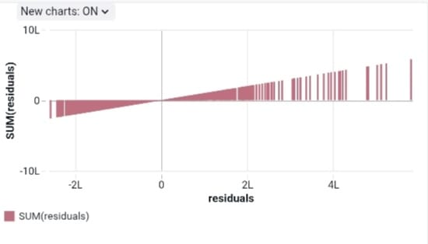
- 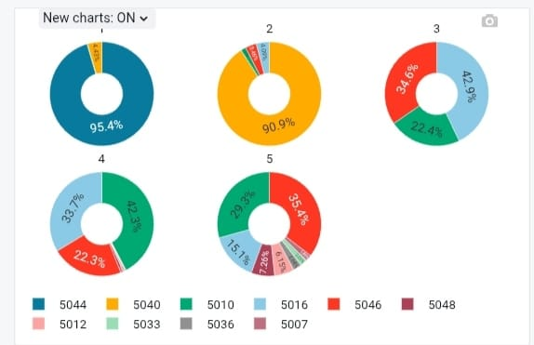

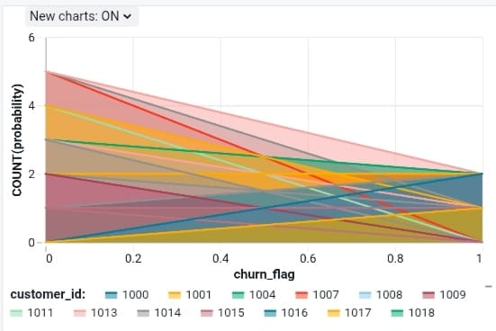
- 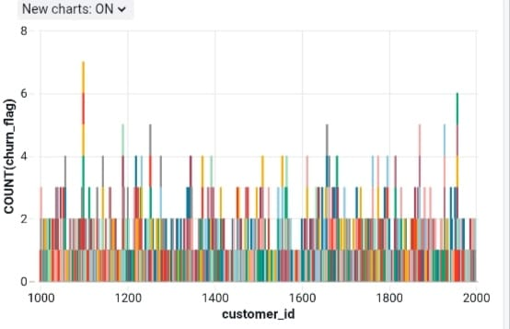
- 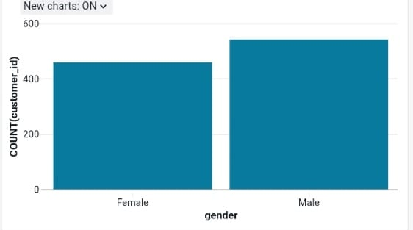

6.
